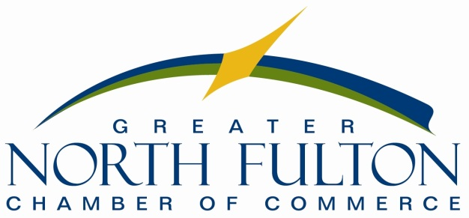

Director of Economic & Talent Development
Job Description

Job Title: Director of Economic & Talent Development
Reports To: President & CEO
Start Date: March 4, 2019

Summary: The Greater North Fulton Chamber of Commerce is currently seeking an energetic, collaborative and dedicated individual to fulfill duties as a full-time Director of Economic & Talent Development. This position will focus on business retention and expansion as well as the talent pipeline for major industries in our community like technology and healthcare.

This position will lead all economic and talent development initiatives for the GNFCC including significant collaborative work with North Fulton municipalities and county economic development executives.

Essential Duties and Responsibilities
- Economic Development/Talent Development Strategy Implementation
- Development and implementation of a Business Retention and Expansion strategy
- Support existing industries with expansion and other projects as needed
- Industry visits and tours in collaboration with City/County/State ED Departments
- Host industry specific events such as Bisnow, Forums, Roundtables, etc.
- Cultivate relationships with company representatives to ensure they become engaged members of business community
- Assist with any aspect requested of their ribbon cutting/grand opening events
- Partner with local jurisdiction to coordinate projects, share information and remind businesses of key deadlines – Freeport Exemption, Opportunity Zones, etc.
- Provide research and data driven deliverables when needed to support BRE/Talent efforts
- Manage related education, non-profit and regional, state and national partnerships
- Serve as North Fulton representative on regional Economic and Workforce Development boards
- CoStar Searches and request for information/project support, etc.
- Coordinate collaborative news stories and print ads– Atlanta Business Chronicle North Fulton Market Report, Georgia Trend, etc.
- Maintain Website Content for BRE/ED and Talent Development/ ED Partners; Create related social media posts and member email content.
- Camera Ready Liaison
- Serve as a presenter/panelist on ED/ Talent related issues and partnerships
This job description reflects management's assignment of essential functions; it does not prescribe or restrict other tasks that may be assigned.

Accountability
This individual reports directly to the President and CEO. Assigned work is performed independently, and this individual must exercise initiative and judgment in the performance of duties. This individual is also responsible for determining the urgency and priority of work when appropriate.

Qualifications
To perform this job successfully, an individual must be able to perform each essential duty satisfactorily. The requirements listed below are representative of the knowledge, skill, and/or ability required. Reasonable accommodations may be made to enable individuals with disabilities to perform the essential functions.

Education/Experience
Bachelor’s degree, ideally with post-graduate work, from an accredited college or equivalent experience; and 3-5 years experience in the economic, community development and/or marketing fields. Preference will be given to Certified Economic Development professionals or individuals in process of achieving certification.

Computer Skills
To perform this job successfully, this position should have experience with:
- Windows software, including Word, Excel, PowerPoint and Outlook
- Social media platforms including, but not limited to: Facebook, Twitter, LinkedIn, Hootsuite, Instagram, and YouTube
- Membership/non-profit database management (specifically ChamberMaster)
- Website management (specifically WordPress websites)
- Email marketing campaigns (specifically Constant Contact)
- Survey creation and execution (specifically Constant Contact)

Job Knowledge/Skills
- Excellent written and verbal communication skills
- Experience in public relations writing, including, but not limited to, writing and distributing press releases, media alerts and social media content
- Ability to work both collaboratively and independently
- Affinity for working with volunteer leaders
- Ability to prioritize and manage multiple projects simultaneously and effectively with a high degree of accuracy
- Have strong customer service focus and relationship building abilities
- Ability to consistently meet project deliverables and deadlines and to follow up rigorously
- Willingness to learn
- Embody a positive, do whatever it takes attitude

The Greater North Fulton Chamber is a high performance, strengths driven organization. We offer a comprehensive compensation and benefits package.

To apply, please send cover letter and resume to Lori Sanders at lsanders@gnfcc.com.

Applications will be accepted through COB Wednesday, January 30, 2019. Est. start date March 4, 2019.

